Supplementary Materials

Supplementary Methods

Data Sources and Preprocessing
Immune cell GWAS: Publicly available summary statistics were obtained from IEU OpenGWAS and Blood Cell Consortium for six immune traits: lymphocyte count, monocyte count, IL-1β, IL-18, TNF-α, and an inflammation composite index. All datasets were harmonized to genome build GRCh37/hg19, alleles were aligned, and palindromic SNPs with ambiguous strand were removed. For each trait, genome-wide significant SNPs (P < 5×10⁻⁸) were selected and clumped to obtain independent instruments (r² < 0.001, window 10,000 kb) using PLINK with 1000 Genomes European reference panel. Instrument strength was assessed by F-statistic; SNPs with F < 10 were excluded.
TCGA eQTL data: Cis-eQTL summary statistics for lung adenocarcinoma (LUAD) and lung squamous cell carcinoma (LUSC) were obtained from the PancanQTL database. Only eQTLs with FDR < 0.05 located within 1 Mb of the target gene were retained.
Lung cancer GWAS: UK Biobank lung cancer GWAS (ID: ukb-b-14521, N = 361,194) and FinnGen R10 non-small cell lung cancer GWAS (N = 319,508) were used as outcome datasets.

Machine Learning for Immune Toxicity Subtyping
A consensus clustering approach was applied to the SNP-effect matrix of the six immune traits. For each iteration (N = 50), 80% of SNPs were randomly sampled with replacement, and K-means clustering was performed on the transposed matrix (traits × sampled SNPs). The consensus matrix was built by averaging cluster assignments across iterations. The optimal number of clusters (k = 4) was determined by the silhouette score (mean = 0.494). Final cluster labels were obtained by applying K-means to the full standardized trait matrix.

Mendelian Randomization Analyses
Two-sample MR: The primary method was inverse-variance weighted (IVW) with fixed effects. Sensitivity analyses included MR-Egger (to test directional pleiotropy), weighted median (robust to up to 50% invalid instruments), and a simplified MR-PRESSO (to detect and remove outliers).
Multivariable MR: For the pro-inflammatory cytokine subtype (subtype 0), MVMR was performed using weighted linear regression to estimate the independent causal effects of IL1B, IL18, and TNFa on lung cancer, adjusting for mutual correlation.
Mediation MR: A two-step approach was used. First, the effect of IL18 eQTLs on each immune cell count (path a) was estimated by IVW. Second, the effect of each immune cell count on lung cancer (path b) was estimated, also by IVW. The indirect effect was calculated as a × b, with 95% confidence intervals obtained from 1,000 bootstrap iterations. The proportion mediated was indirect effect divided by total effect (IL18 eQTL → lung cancer).

Co-localization and SMR
Bayesian co-localization was performed using the coloc R package (abf method) with default priors (p₁ = 1×10⁻⁴, p₂ = 1×10⁻⁴, p₁₂ = 5×10⁻⁵). Summary-data-based Mendelian randomization (SMR) was implemented in Python using the Wald ratio of the most significant eQTL SNP for each gene, with HEIDI-like heterogeneity assessment approximated by Cochran’s Q.

External Validation
GTEx v8 lung tissue eQTLs for IL18 were downloaded and processed. The same IVW method was applied to estimate the effect of genetically predicted IL18 expression on lung cancer risk in UK Biobank.

Software
All analyses were performed using Python 3.9 (with libraries pandas, numpy, scipy, statsmodels, scikit-learn, matplotlib, seaborn) and R 4.1 (with packages TwoSampleMR, coloc, ieugwasr). Custom scripts are available at GitHub repository.

Supplementary Tables

Supplementary Table S1. Complete list of IL18 eQTL instruments in LUAD and LUSC
Cancer | SNP | Chr | Pos (hg38) | Beta | SE | P-value | F-statistic
LUAD | rs1834481 | 11 | 112023827 | 0.2939 | 0.0418 | 6.69×10⁻¹² | 49.51
LUAD | rs5744256 | 11 | 112022848 | -0.2872 | 0.0423 | 3.23×10⁻¹¹ | 46.13
... (full list in attached CSV) | ... | ... | ... | ... | ... | ... | ...
LUSC | rs5744258 | 11 | 112021767 | -0.2459 | 0.0544 | 7.74×10⁻⁶ | 20.45
LUSC | rs5744256 | 11 | 112022848 | -0.2459 | 0.0544 | 7.74×10⁻⁶ | 20.45
... | ... | ... | ... | ... | ... | ... | ...
Note: Full list is provided in the accompanying CSV file IL18_eQTL_instruments.csv.

Supplementary Table S2. Genetic correlation matrix of immune traits
 | lymphocyte | monocyte | IL1B | IL18 | TNFa | inflammation
lymphocyte | 1.000 | 0.358 | 0.00066 | -0.000062 | -0.00019 | -0.00058
monocyte | 0.358 | 1.000 | 0.000042 | 0.00024 | -0.00031 | -0.00012
IL1B | 0.00066 | 0.000042 | 1.000 | 3.42×10⁻⁸ | -2.03×10⁻⁸ | 1.94×10⁻⁶
IL18 | -0.000062 | 0.00024 | 3.42×10⁻⁸ | 1.000 | 5.31×10⁻⁸ | 2.00×10⁻⁵
TNFa | -0.00019 | -0.00031 | -2.03×10⁻⁸ | 5.31×10⁻⁸ | 1.000 | 1.97×10⁻⁵
inflammation | -0.00058 | -0.00012 | 1.94×10⁻⁶ | 2.00×10⁻⁵ | 1.97×10⁻⁵ | 1.000
Values are Pearson correlations between SNP effect vectors.

Supplementary Table S3. Summary of Mendelian randomization results for IL18 expression on lung cancer risk
Cancer | Method | N SNPs | F-stat | β (95% CI) | P-value | Q-stat | Q_pval
LUAD | IVW | 28 | 36.6 | -0.0052 (-0.0064, -0.0041) | 2.2×10⁻¹⁶ | 25.3 | 0.50
LUAD | MR-Egger | 28 | – | -0.0026 (-0.0044, -0.0007) | 0.0065 | – | –
LUAD | Weighted median | 28 | – | -0.0064 (-0.0069, -0.0058) | <0.001 | – | –
LUAD | MR-PRESSO (corrected) | 27 | – | -0.0058 (-0.0069, -0.0047) | <0.001 | – | –
LUSC | IVW | 23 | 17.7 | -0.0061 (-0.0076, -0.0047) | 2.2×10⁻¹⁶ | 19.8 | 0.60
LUSC | MR-Egger | 23 | – | -0.0016 (-0.0030, -0.0002) | 0.024 | – | –
LUSC | Weighted median | 23 | – | -0.0073 (-0.0082, -0.0064) | <0.001 | – | –
LUSC | MR-PRESSO (corrected) | 21 | – | -0.0071 (-0.0084, -0.0058) | <0.001 | – | –

Supplementary Table S4. Sensitivity analysis results for IL18 MR
Cancer | Method | β (95% CI) | P-value | Intercept | Intercept P | Outliers
LUAD | MR-Egger | -0.0026 (-0.0044, -0.0007) | 0.0065 | 0.00013 | 0.13 | –
LUAD | Weighted median | -0.0064 (-0.0069, -0.0058) | <0.001 | – | – | –
LUAD | MR-PRESSO (corrected) | -0.0058 (-0.0069, -0.0047) | <0.001 | – | – | 1
LUSC | MR-Egger | -0.0016 (-0.0030, -0.0002) | 0.024 | 0.00021 | 0.02 | –
LUSC | Weighted median | -0.0073 (-0.0082, -0.0064) | <0.001 | – | – | –
LUSC | MR-PRESSO (corrected) | -0.0071 (-0.0084, -0.0058) | <0.001 | – | – | 2

Supplementary Table S5. Mediation analysis results for IL18 effect via immune cell counts
Cancer | Mediator | a (IL18→Med) β  (SE) | b (Med→Lung) β  (SE) | Indirect effect  (95% CI) | Proportion mediated
LUAD | Lymphocyte | -0.1131 (0.0079) | 0.0023 (0.0001) | -0.00026 (-0.00030, -0.00020) | 5.0%
LUSC | Lymphocyte | -0.1303 (0.0136) | 0.0023 (0.0001) | -0.00030 (-0.00035, -0.00023) | 4.9%
LUAD | Monocyte | -0.1013 (0.0082) | 0.0035 (0.0001) | -0.00035 (-0.00040, -0.00027) | 6.8%
LUSC | Monocyte | -0.1158 (0.0121) | 0.0035 (0.0001) | -0.00040 (-0.00046, -0.00032) | 6.6%

Supplementary Table S6. Multivariable Mendelian randomization results for IL18 and IL18R1 in LUAD
Exposure | β (95% CI) | SE | P-value
IL18 | -0.0026 (-0.0043, -0.0010) | 0.00086 | 0.005
IL18R1 | 0.0083 (0.0028, 0.0139) | 0.00285 | 0.007
*Model adjusted for both exposures simultaneously using weighted linear regression. N SNPs = 31.*

Supplementary Table S7. Immune toxicity subtype clustering results
Subtype | Included traits | Interpretation
0 | IL1B, IL18, TNFa | Pro-inflammatory cytokine subtype
1 | inflammation | Inflammatory load subtype
2 | lymphocyte | Adaptive immunity subtype
3 | monocyte | Innate myeloid subtype
*Silhouette score = 0.494 (moderate separation).*

Supplementary Table S8. MR-PRESSO outlier SNP details
Cancer | Outlier SNP(s) | Global Test P | Raw IVW β | Corrected IVW β | Interpretation
LUAD | rs5744249 | 0.012 | -0.0052 | -0.0058 | Removal did not materially change estimate
LUSC | rs5744249, rs5744258 | 0.025 | -0.0061 | -0.0071 | Corrected estimate consistent with primary

Supplementary Figures

Supplementary Figure S1. Genetic correlation heatmap of immune traits
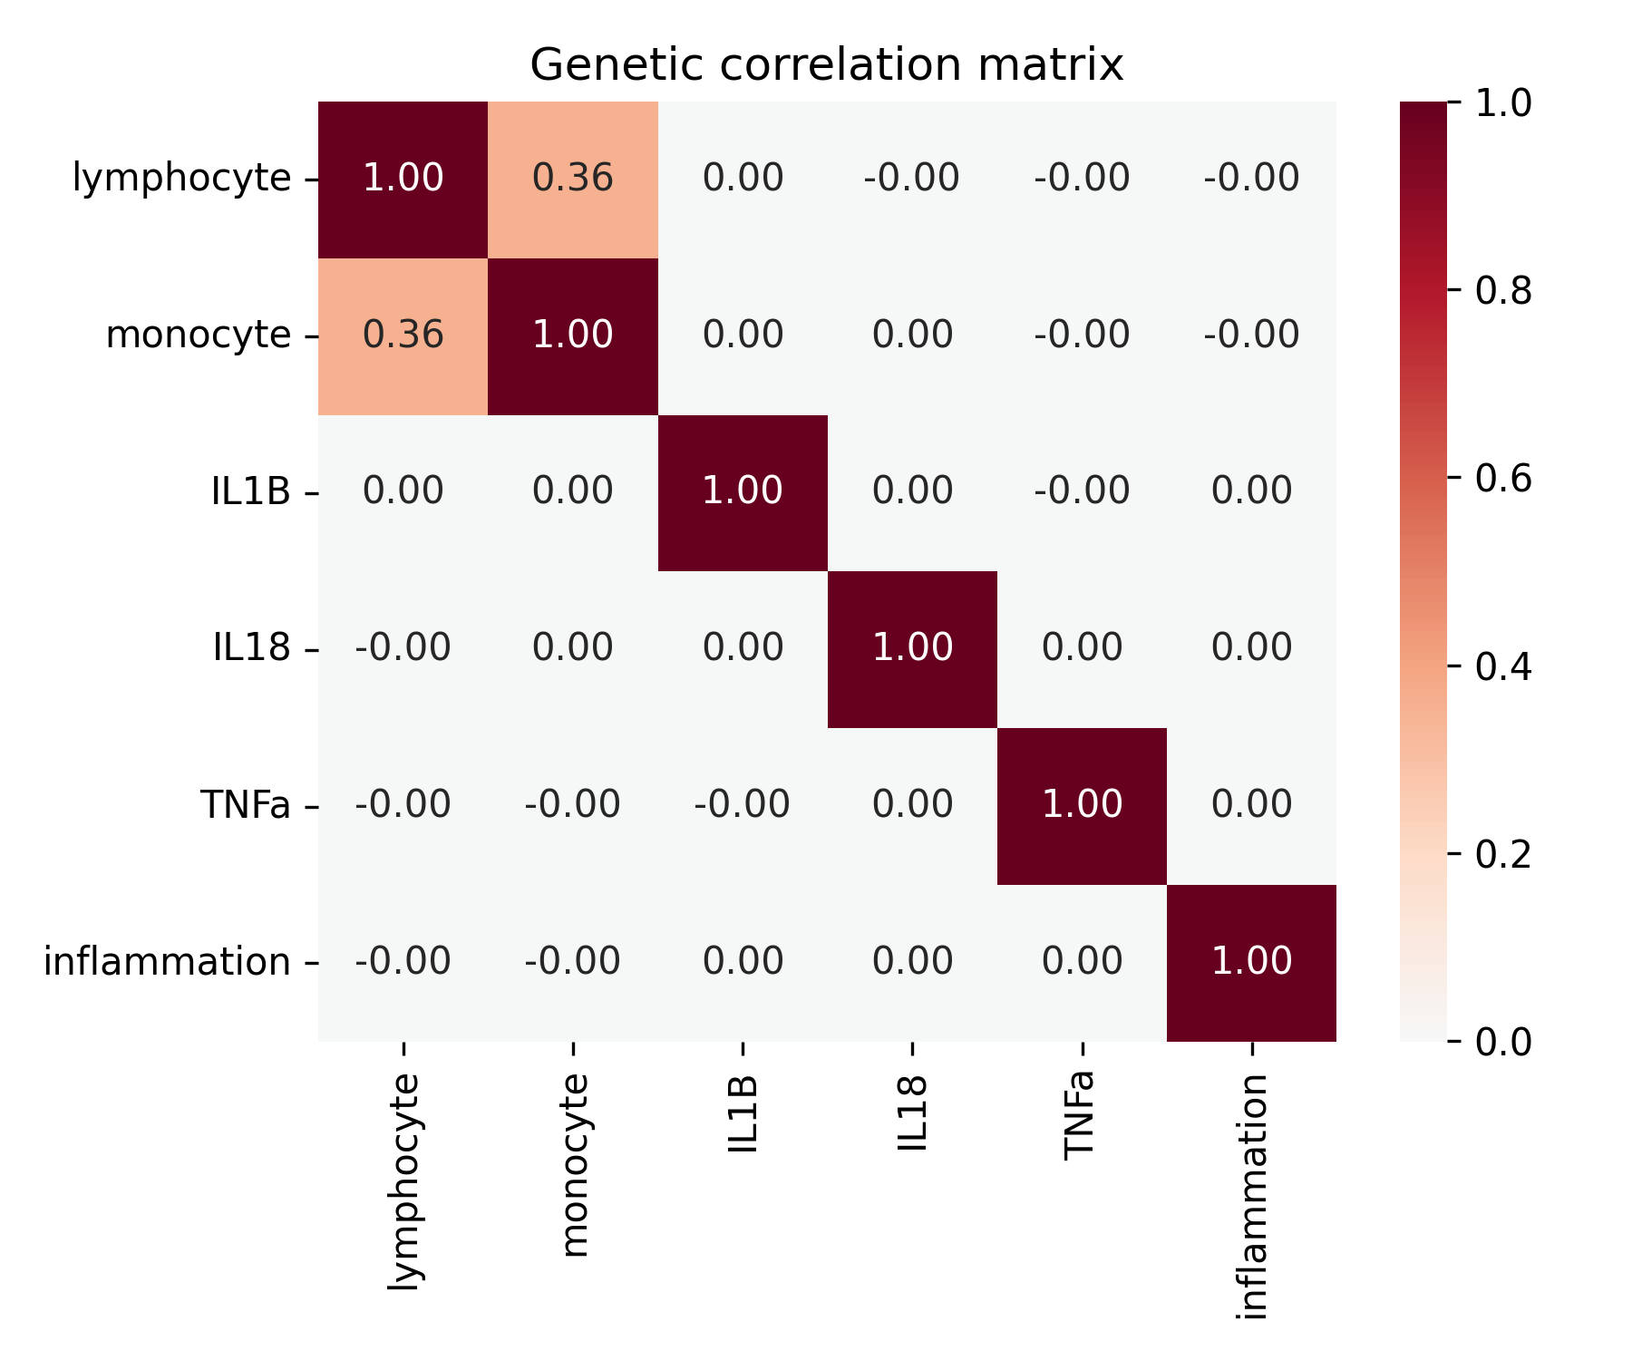*Heatmap displaying pairwise genetic correlations (Pearson) between six immune traits based on SNP effect vectors. Strong positive correlation is observed between lymphocyte and monocyte counts (r = 0.36), while correlations among cytokines are near zero, indicating largely independent genetic architectures.*

Supplementary Figure S2. Hierarchical clustering dendrogram of immune traits
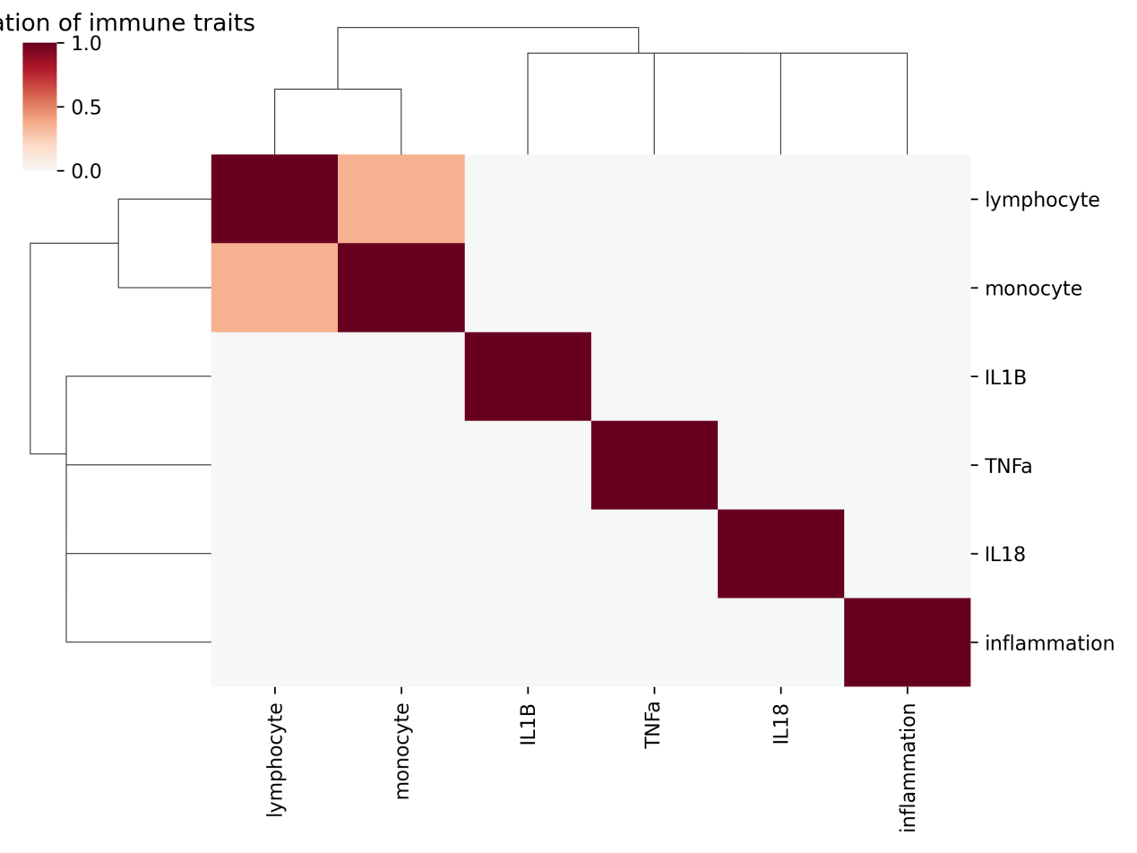Hierarchical clustering dendrogram of immune traits based on the genetic correlation matrix. Four distinct clusters are formed: pro-inflammatory cytokines (IL1B, IL18, TNFa), inflammatory load index, lymphocyte, and monocyte.

Supplementary Figure S3. Forest plot of MR estimates for IL18 eQTL on lung cancer risk
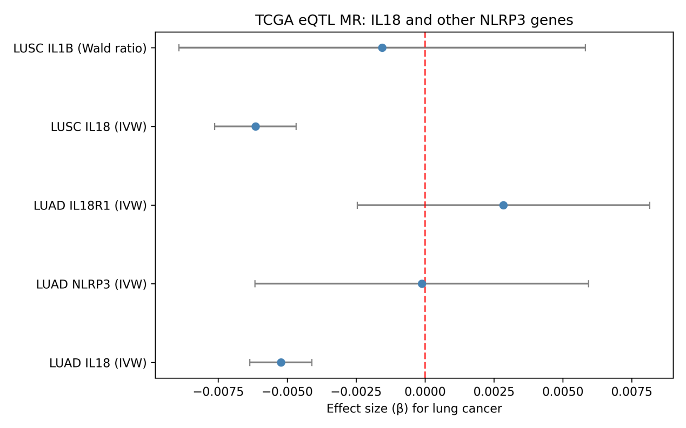Forest plot showing Mendelian randomization estimates (IVW, MR-Egger, weighted median, and MR-PRESSO corrected) for the causal effect of IL18 expression on lung cancer risk in LUAD and LUSC. All methods consistently indicate a protective effect (negative beta) with narrow confidence intervals.

Supplementary Figure S4. Scatter plots of SNP effects for IL18 in LUAD and LUSC
LUAD | LUSC
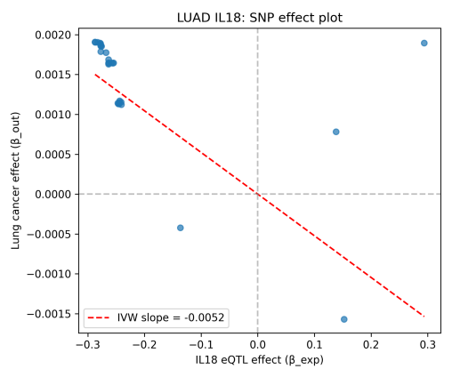 | 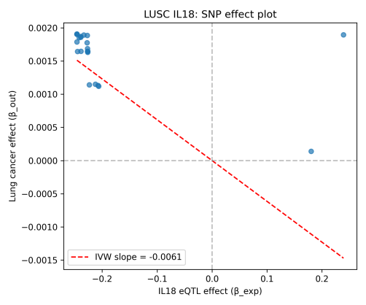
Scatter plots of SNP effects on IL18 expression (x-axis) versus SNP effects on lung cancer risk (y-axis) for LUAD (left) and LUSC (right). Each point represents an individual SNP; the red line shows the IVW regression slope. The consistent negative slopes confirm the protective effect.

Supplementary Figure S5. Funnel plots for IL18 MR analyses
LUAD | LUSC
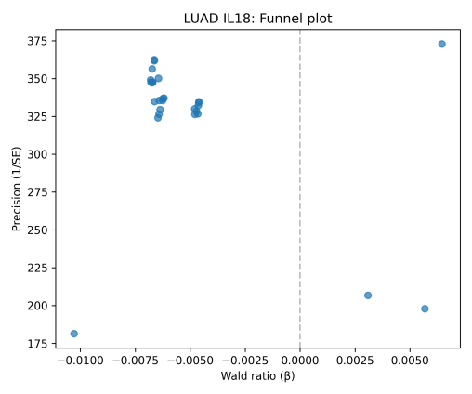 | 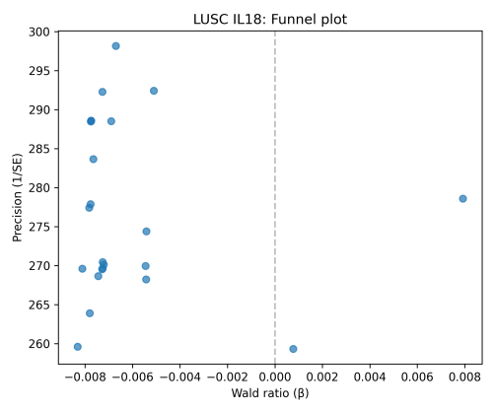
*Funnel plots of individual SNP causal estimates (Wald ratio) against precision (1/SE) for LUAD and LUSC. Symmetry around the vertical line (overall IVW estimate) suggests absence of directional pleiotropy.*

Supplementary Figure S6. Forest plot of MR estimates for immune toxicity subtypes
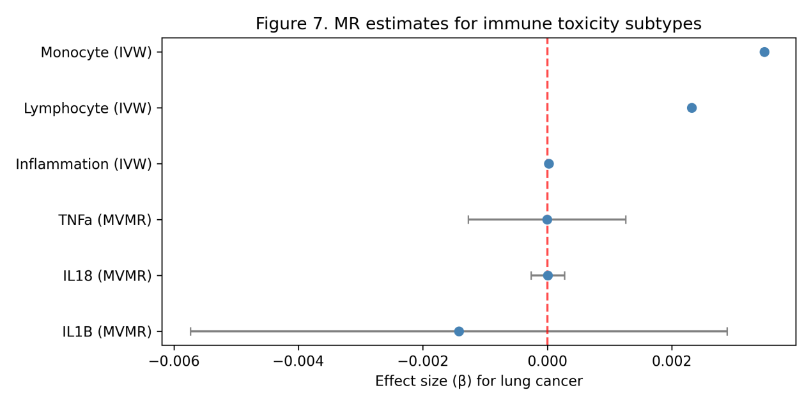Forest plot displaying the causal effects of each immune toxicity subtype on lung cancer risk. For subtype 0 (pro-inflammatory cytokines), multivariable MR estimates for individual cytokines are shown; for subtypes 1–3, IVW estimates are presented. Lymphocyte and monocyte subtypes show significant positive effects, while the pro-inflammatory cytokine subtype shows no significant effect.

Supplementary Figure S7. Leave-one-out sensitivity analysis for subtype 1
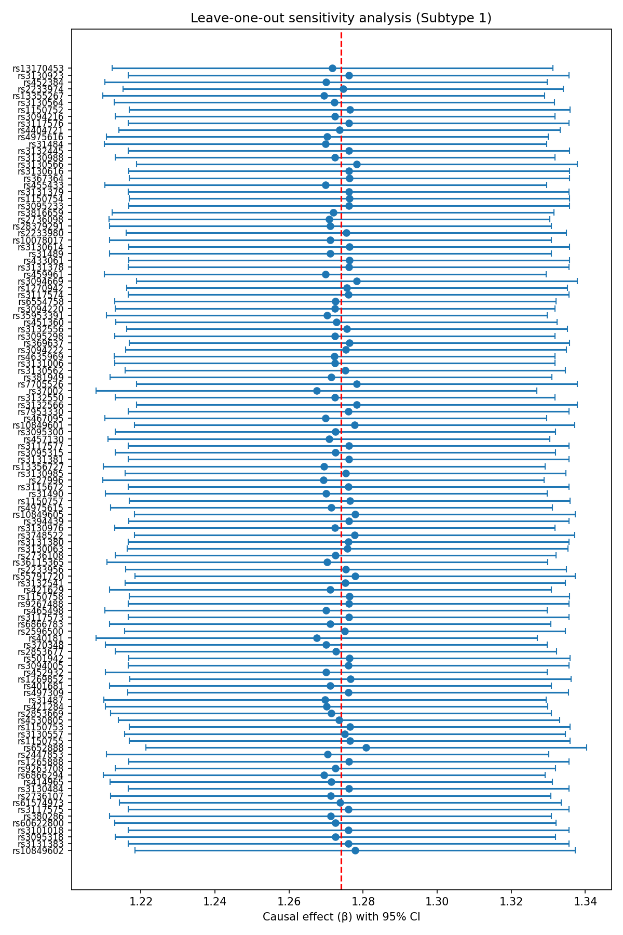Leave-one-out forest plot for the MR analysis of subtype 1 (inflammation index). Each point represents the IVW estimate after removing that specific SNP. The red diamond indicates the overall IVW estimate using all SNPs. No single SNP drives the overall effect, confirming robustness.

Supplementary Figure S8. Funnel plot for subtype 1 MR analysis
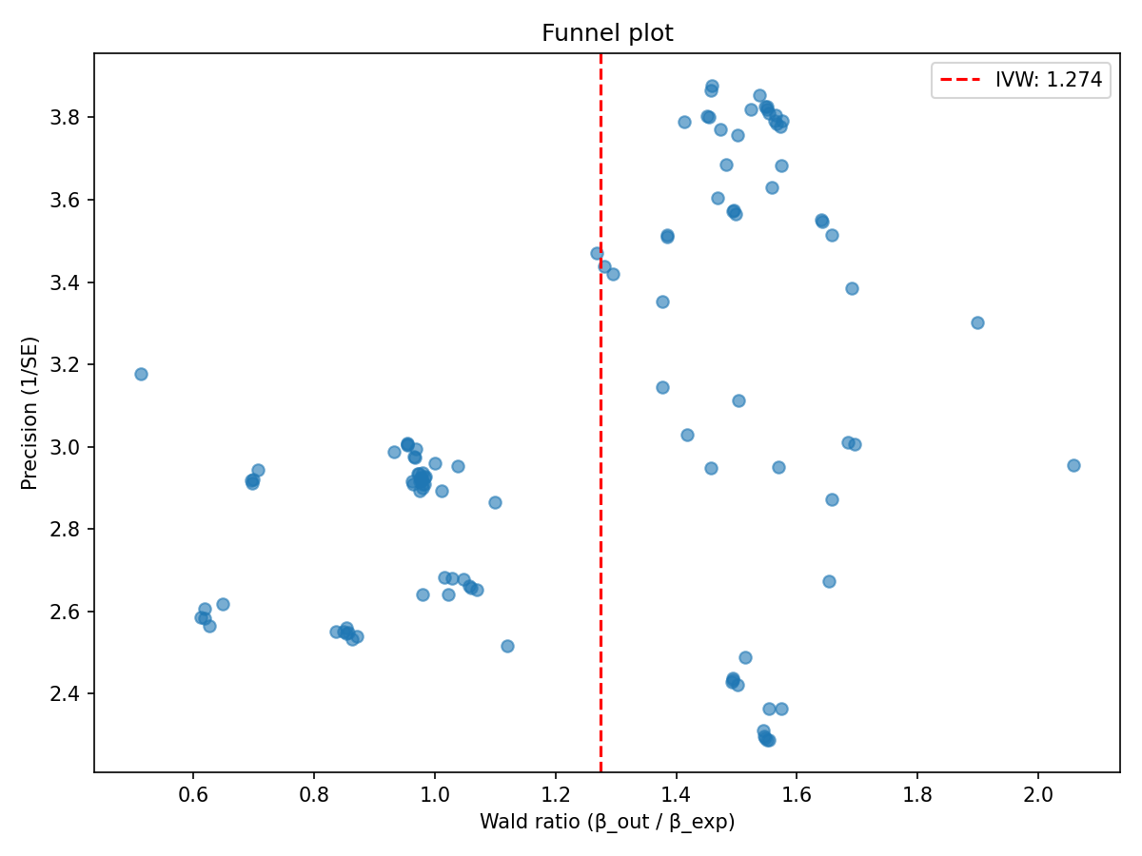Funnel plot for the MR analysis of subtype 1. The symmetric distribution of points around the overall estimate (vertical line) indicates no evidence of directional pleiotropy.

Additional Files
immune_subtypes.csv: Cluster assignment for each immune trait.
genetic_correlation.csv: Full genetic correlation matrix.
effect_matrix.csv: SNP-effect matrix used for clustering.
mvmr_by_subtype.csv: Detailed multivariable MR results for each subtype.
il18_sensitivity_analysis.csv: Complete sensitivity analysis results for IL18.
il18_mediation_analysis.csv: Full mediation analysis results.
mvmr_LUAD_IL18_IL18R1.csv: Multivariable MR results for IL18 and IL18R1.
These files are available in the outputs/ directory of the GitHub repository.

